**Project Design Phase-II**

**Solution Requirements (Functional & Non-functional)**

|  |  |
| --- | --- |
| Date | Date: 26 June 2025 |
| Team ID | Team ID: LTVIP2025TMID44725 |
| Project Name | Poultry Disease Detection Using Transfer Learning |
| Maximum Marks | 4 Marks |

**Functional Requirements:**

Following are the functional requirements of the proposed solution.

|  |  |  |
| --- | --- | --- |
| FR No. | Functional Requirement (Epic) | Sub Requirement (Story / Sub-Task) |
| FR-1 | Image Upload | Upload poultry image via form |
| FR-2 | Prediction Result | Display disease prediction result |
| FR-3 | User Feedback | Allow user to submit feedback on prediction |
| FR-4 | Admin Module | Manage model versions and view logs |

**Non-functional Requirements:**

Following are the non-functional requirements of the proposed solution.

|  |  |  |
| --- | --- | --- |
| FR No. | Non-Functional Requirement | Description |
| NFR-1 | Usability | User-friendly interface for non-technical users |
| NFR-2 | Security | Secured data transfer and storage |
| NFR-3 | Reliability | System should consistently deliver correct predictions |
| NFR-4 | Performance | Quick processing and response time |
| NFR-5 | Availability | Accessible with minimal downtime |
| NFR-6 | Scalability | System should scale with increasing user base |

**Visual Architecture Reference**

The following diagram illustrates the technical architecture and flow of the system:

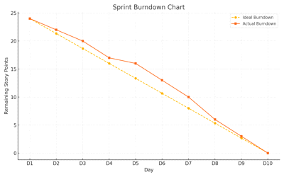

Figure: Burndown Chart showing progress of sprint tasks over time.